**Adding a Child domain to an existing Parent Domain, in a forest 🡪 Subdomain to an existing domain in an existing forest**

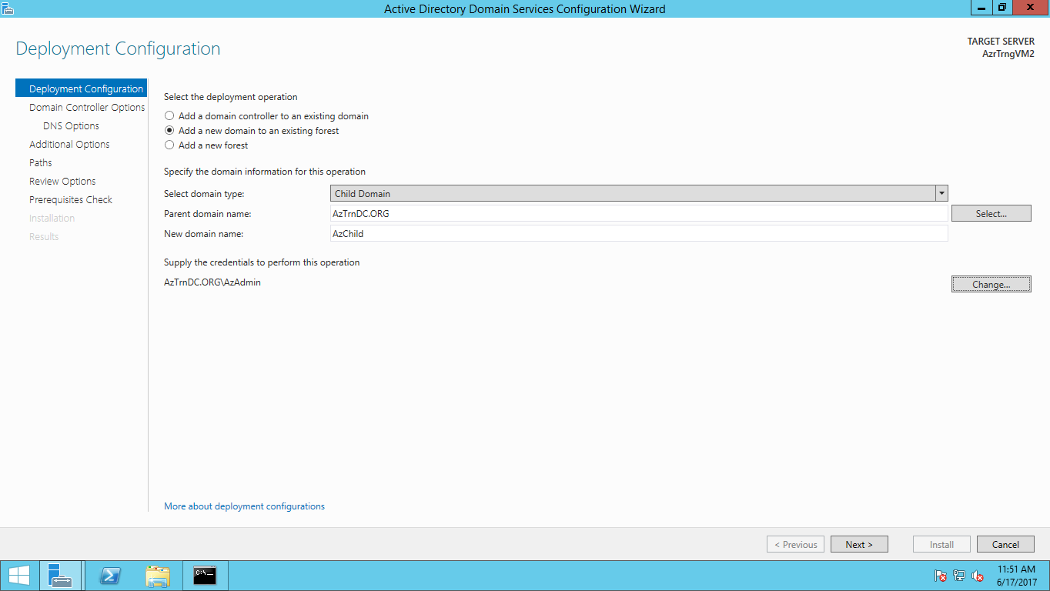

**It seems every NEW domain’s Domain Controller will have a separate Global Catalog. Please research and update**

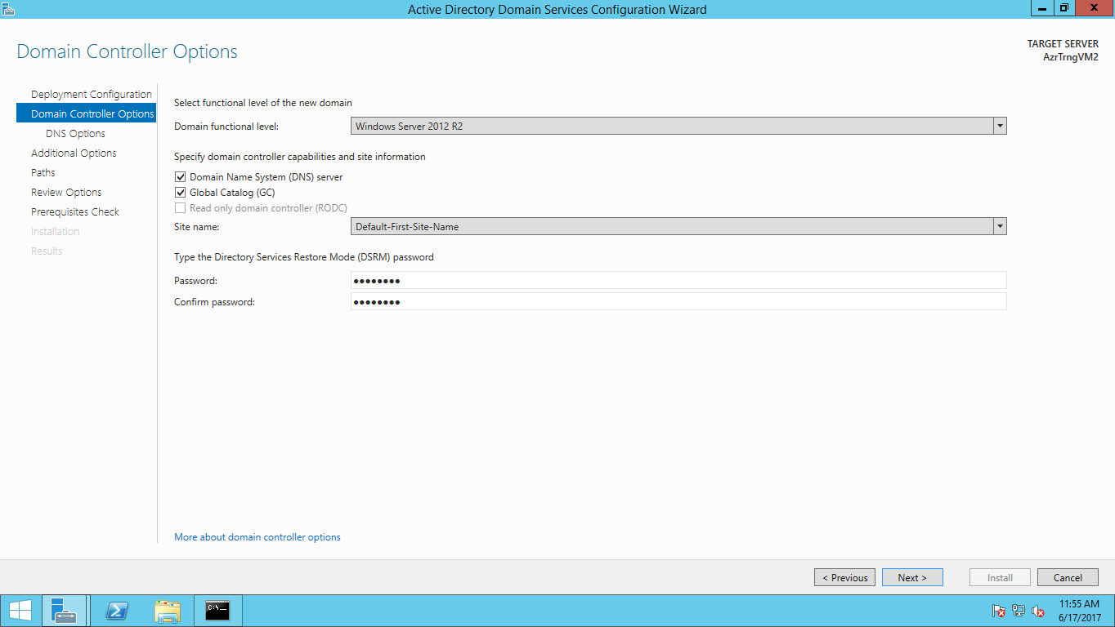

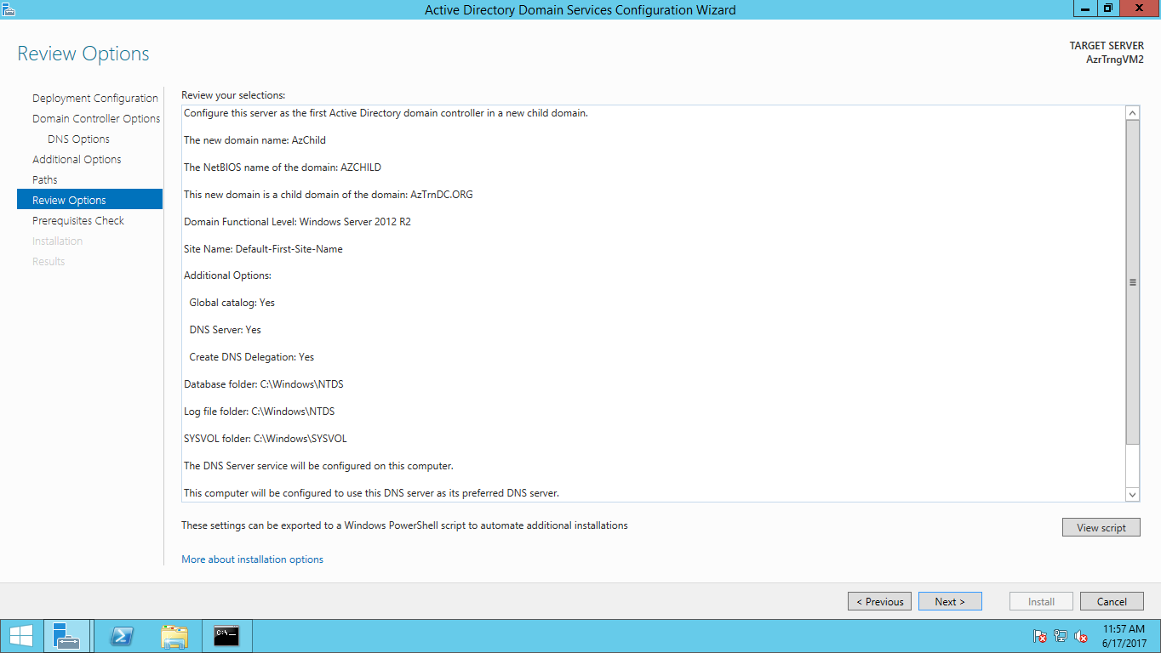

**I forgot to configure Static IP address for the Primary NIC. This is important for Domain Controller configuration. There are mechanisms in Azure or any cloud to make a NIC’s Private IP address (Internal IP Address) to be static.**

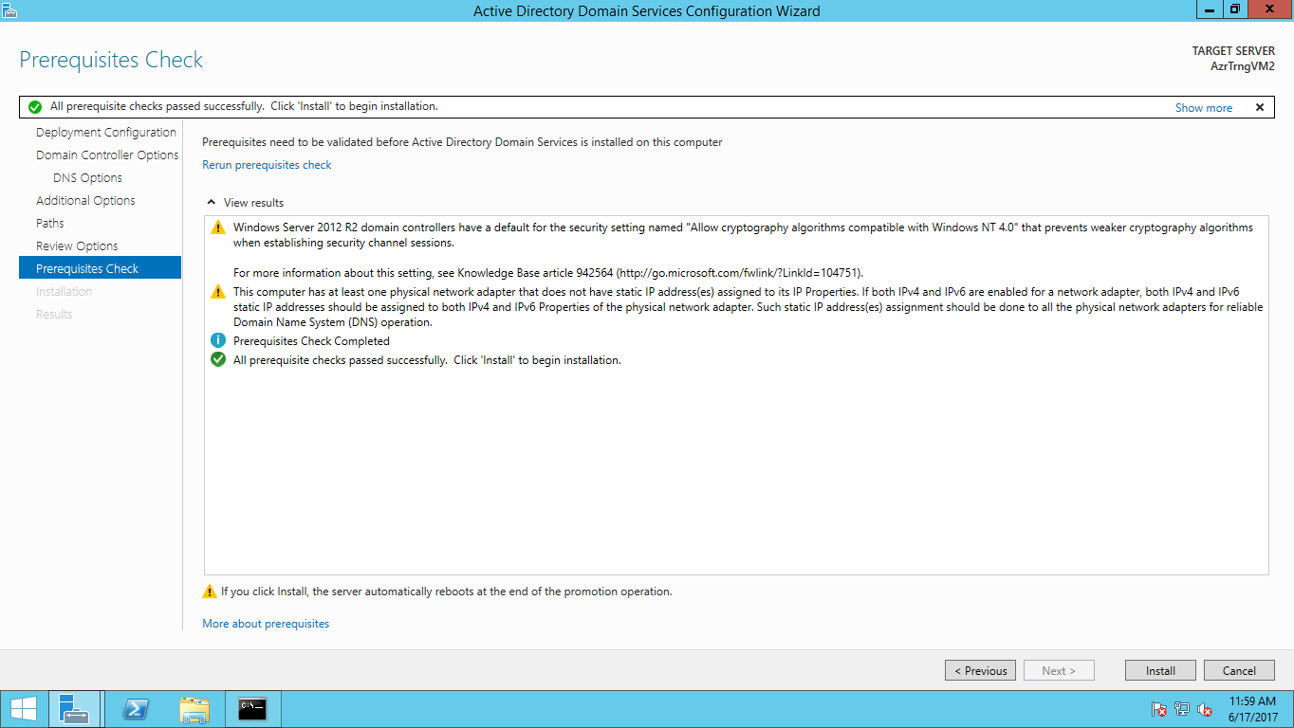

**Trust establishment (Implicit / Automatic) between the Parent and Child Domain**

**Parent domain trust configuration**

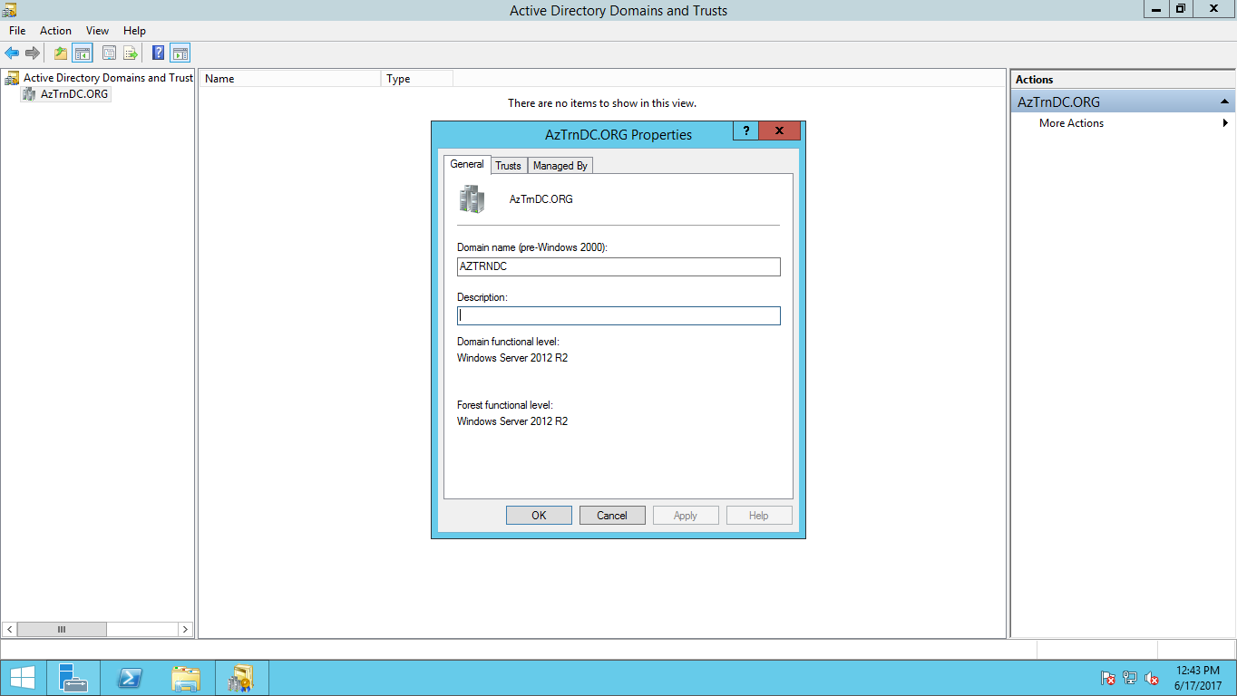

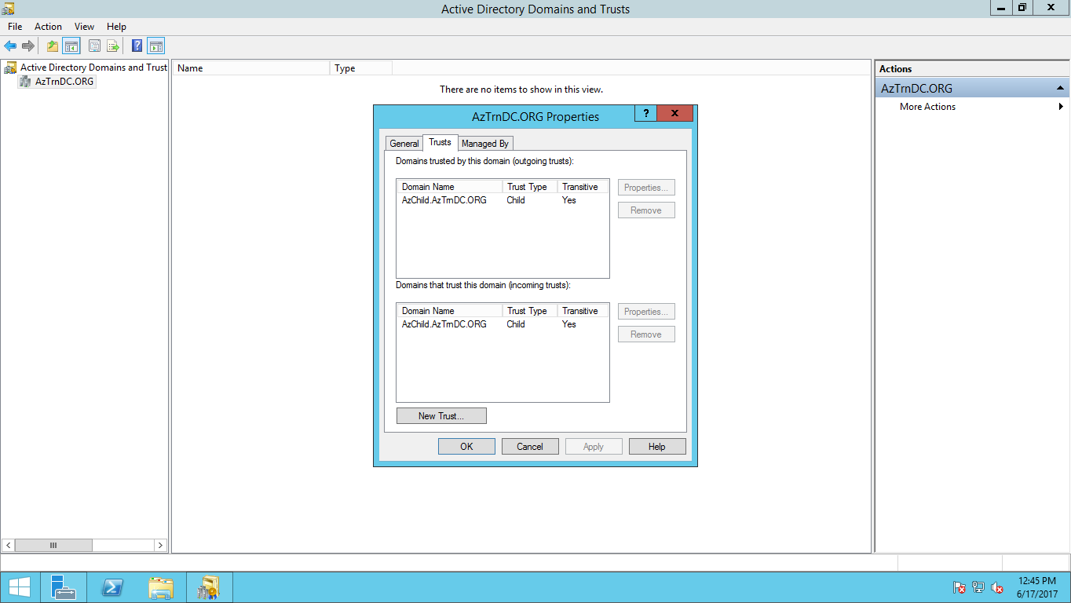

**Child domain trust configuration**

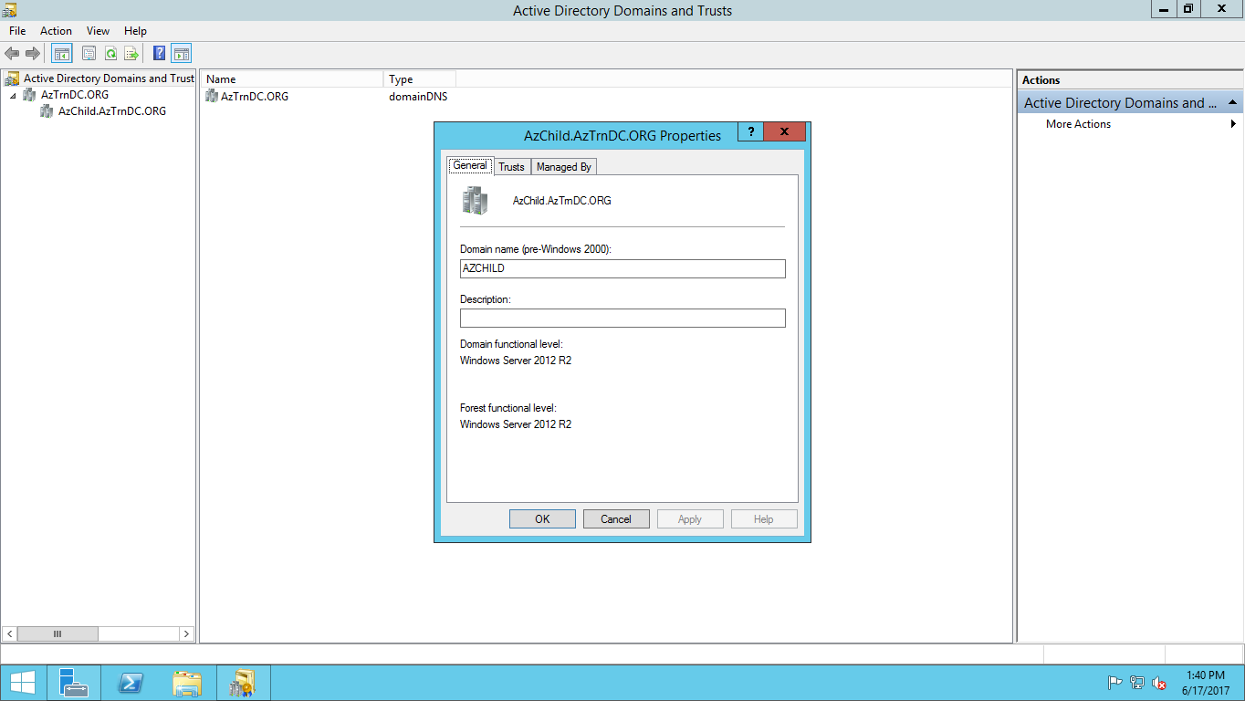

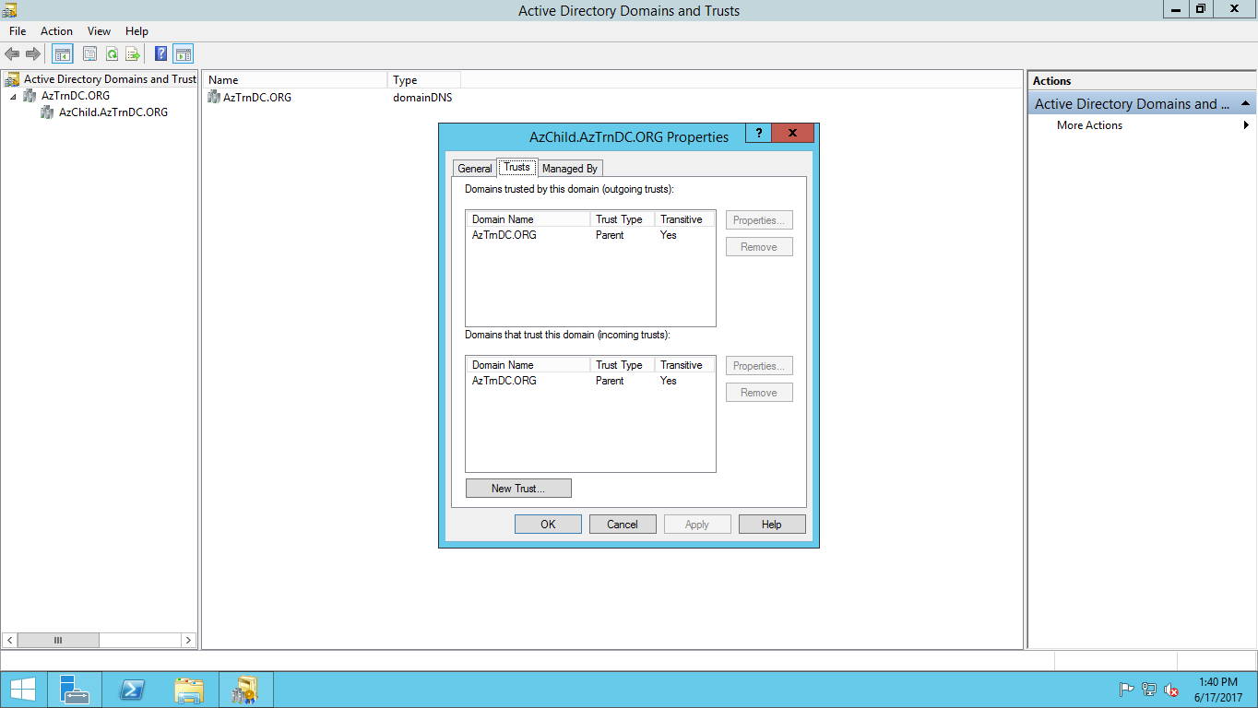

**Adding a Tree domain to an existing Forest 🡪 Domain Tree (New domain) in an existing forest**

**Creating a new forest**

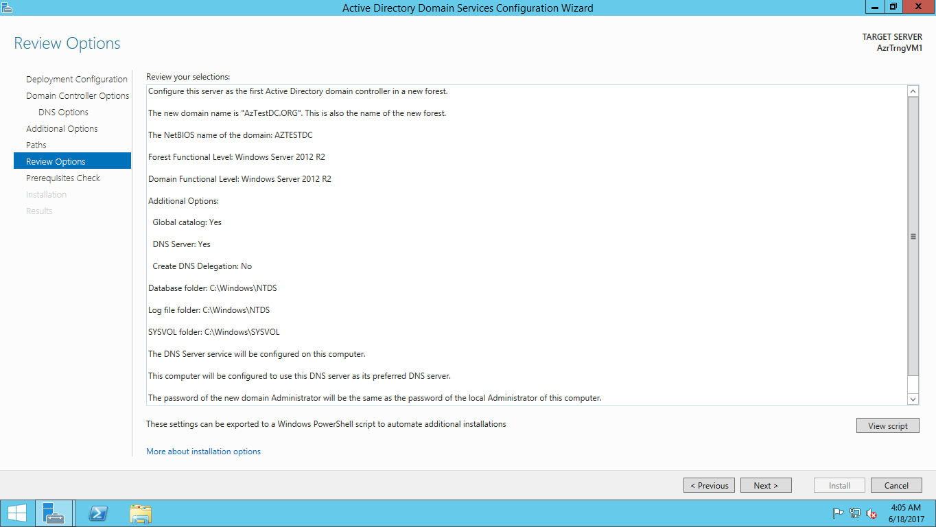

**Creating a Domain Tree in the same forest**

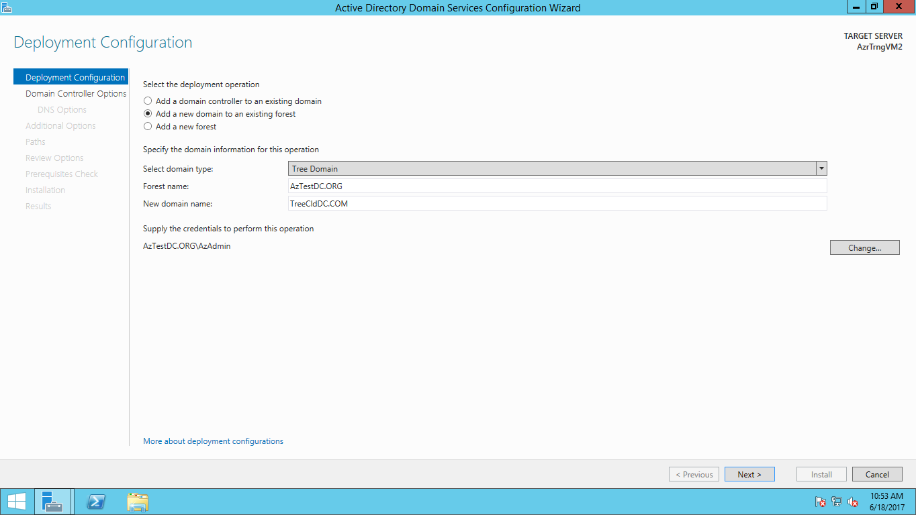

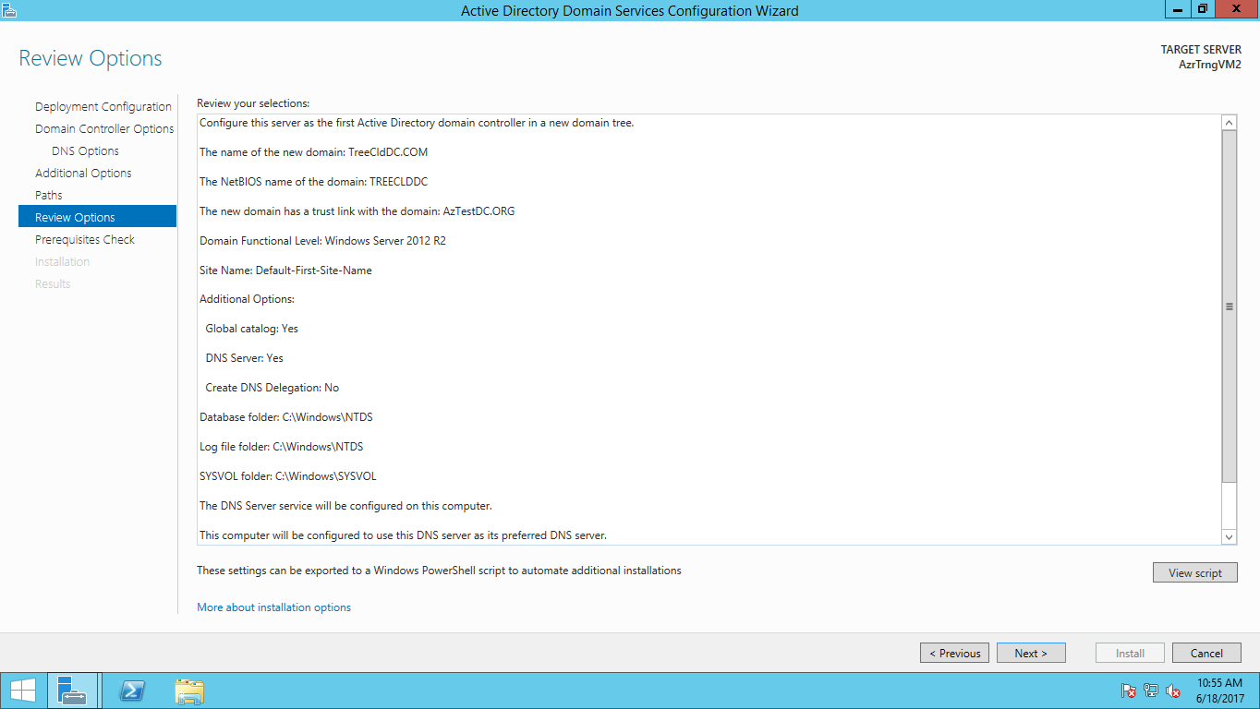

**Notice 2 different domain trees in the left pane, but trust between the domains is still implicit**

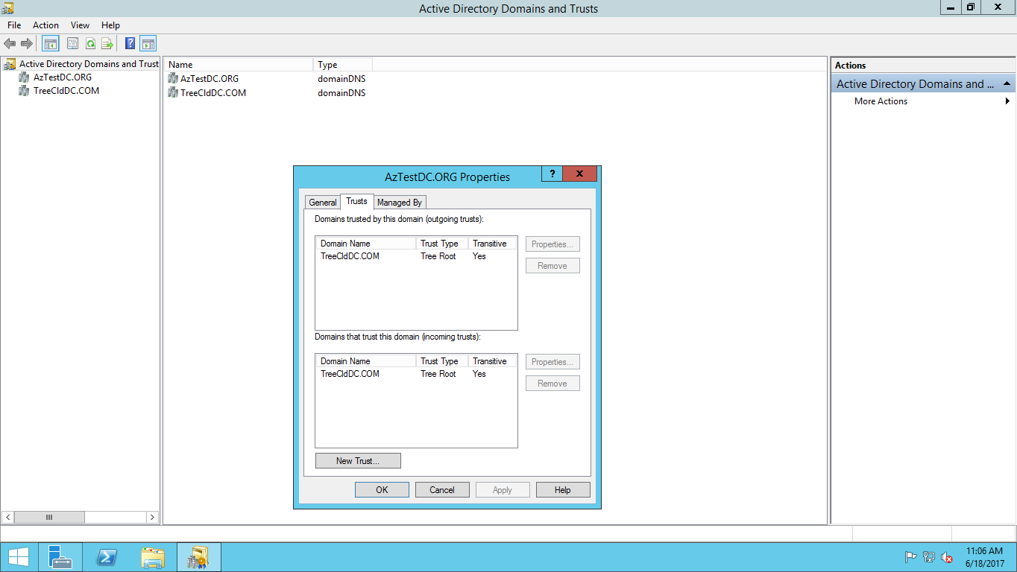

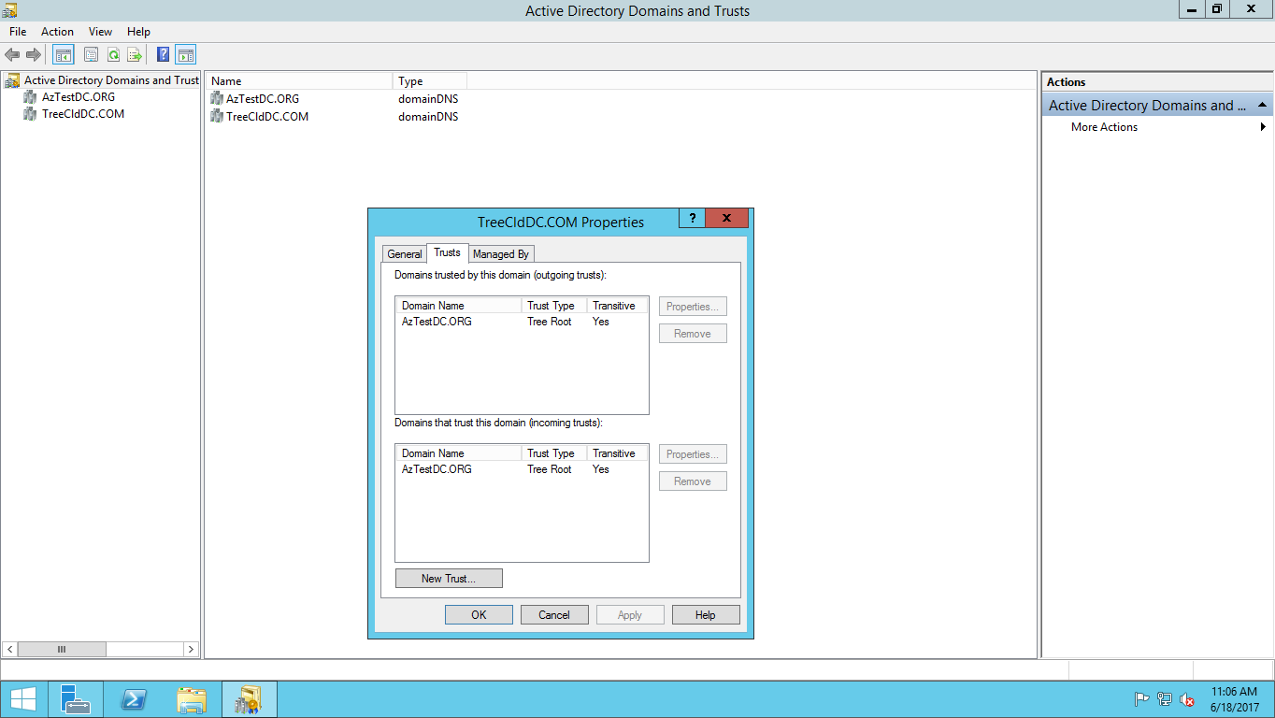

**Same applies to Forest wide trust between 2 forests, except for the fact that the trust has to be established explicitly.**